**Experiment 8: write an Arduino program to turn LED ON and OFF using LDR with Arduino Uno.**

**INTERFACING LDR**

AIM: To write an Arduino program to turn LED ON and OFF using LDR with Arduino Uno.

**APPARATUS REQUIRED:**

1. PC

2. Arduino IDE

3. LDR

4. Bread Board-1No

5. Resistors-10K Ω, 220Ω-1No

6. LDR-1No

7. Wires

**CIRCUIT DIAGRAM:**

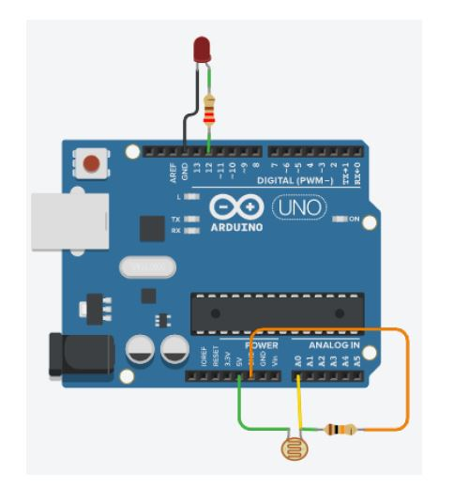

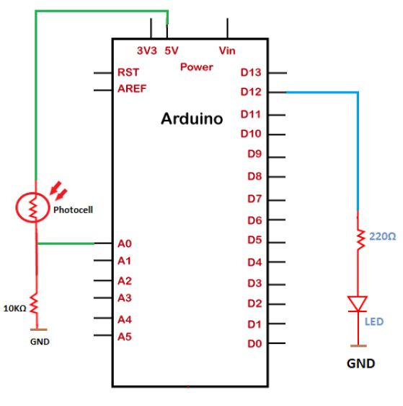

**PROCEDURE:**

1. Connect the circuit as per the circuit diagram.

2. Connect Arduino to your PC.

3. Open the Arduino IDE in computer and write the program.

4. Compile the program for any errors and upload it to the Arduino.

5. Observe the output LED ON AND OFF.

**PROGRAM:**

const int ledPin = 13;

const int ldrPin = A0;

void setup() {

Serial.begin(9600);

pinMode(ledPin, OUTPUT);

pinMode(ldrPin, INPUT);

}

void loop() {

int ldrStatus = analogRead(ldrPin);

if (ldrStatus <= 300) {

digitalWrite(ledPin, HIGH);

Serial.print("Its DARK, Turn on the LED : ");

Serial.println(ldrStatus);

} else {

digitalWrite(ledPin, LOW);

Serial.print("Its BRIGHT, Turn off the LED : ");

Serial.println(ldrStatus);

}

}

**RESULT:** Thus the LED is switched ON, OFF by LDR using Arduino Uno.